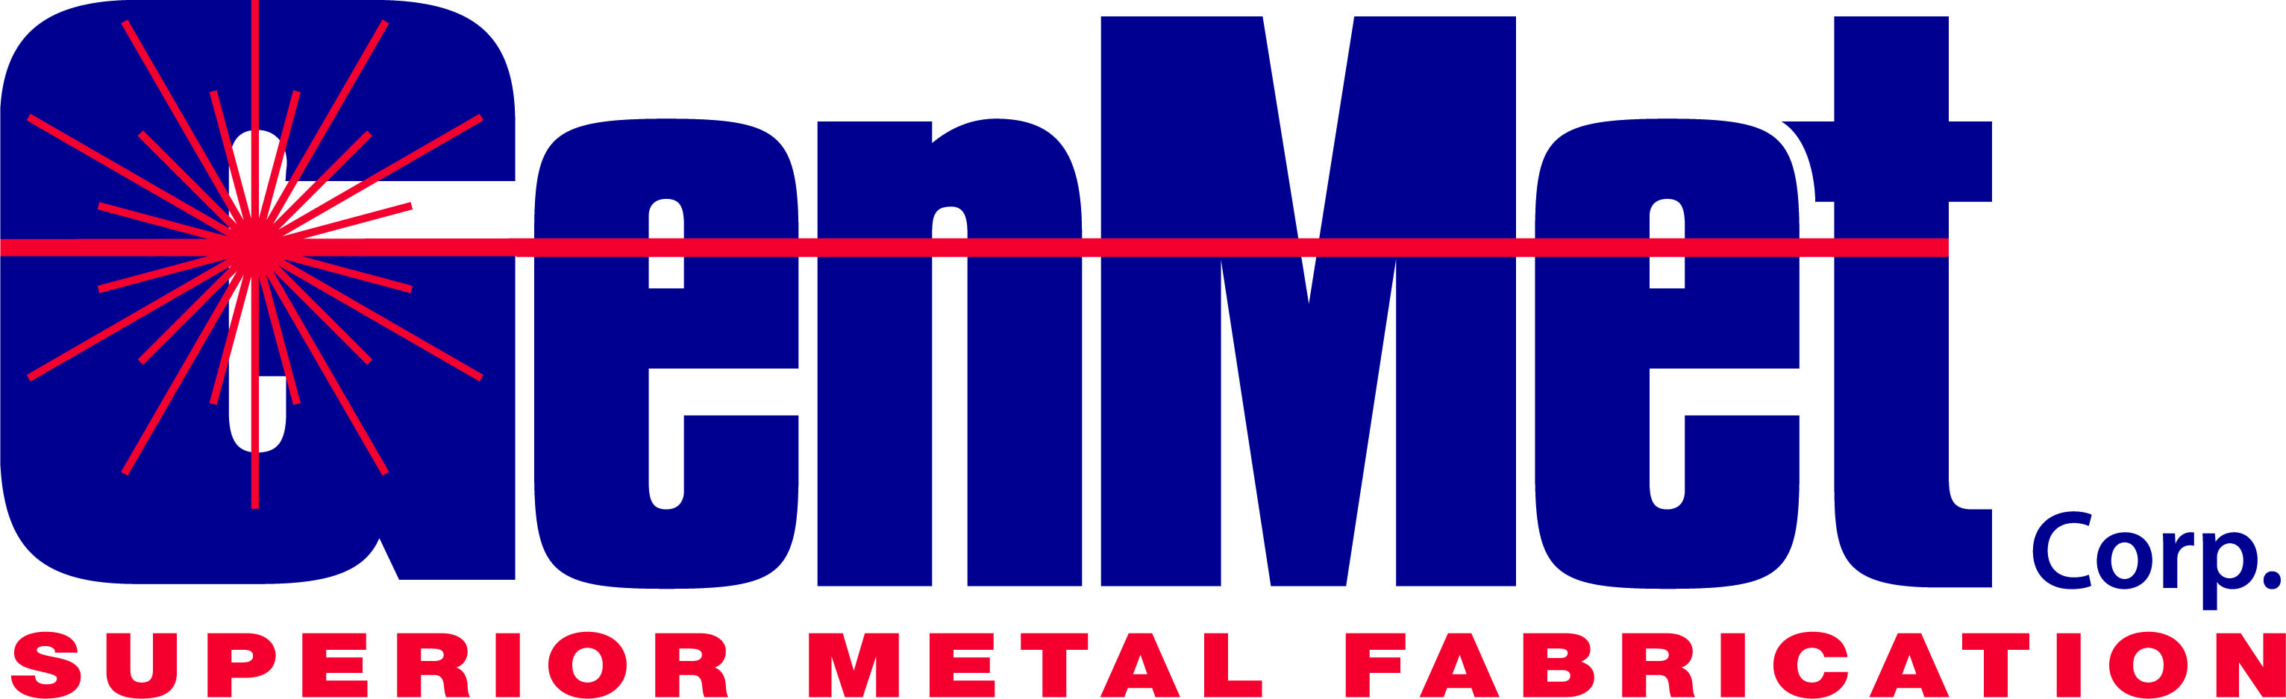

Job Description: CNC Machinist
___________________________________________________________________

Summary:
Machinists are responsible for assuring that all metal fabricated parts manufactured by GenMet Corp are made safely and meet our Customer’s specifications.

Essential Duties and Responsibilities include but are not limited to the following:
.
- Set up and run a single or multiple machines (saws, lathes, mills, grinders, hand tools)
- Produce parts off of CNC machines per print
- Program at the machine using Mazatrol and G code
- Set tools and make necessary adjustments to offsets to produce wide variety of close tolerance parts per print
- Post programs on the shop floor machines
- Complete in process inspections
- Make parts according to production schedule
- Accurately clocking in and out of jobs for reporting purposes
- Improve and maintain cleanliness and order (5s)
- Follow business practices such as routine preventative maintenance, housekeeping of work area, safety, and attendance policies

Educational and Other Requirements
- Two year Technical Associates Degree or a minimum of 3 years applicable experience.

Skills/Qualifications:
- Extensive metal fabrication blueprint reading and interpretation knowledge and experience (including Geometric Dimensioning and Tolerancing)
- Knowledge of machining practices and process involving speeds and feeds, operation sequences, and tooling and procedures required for product tolerances
- Ability to read blueprints and measure parts with precision tools (calipers, micrometers, depth gauges, thread gauges, etc.)
- Required mathematical skills: ability to add, subtract, multiply, divide, work with decimals, fractions and percentages
- Must have the ability to learn quickly and have good communication and teamwork skills
- Must be able to lift and carry 50 pounds
- Ability and willingness to solve problems, suggest improvements and manage schedules

Cultural Requirements
- Demonstrate uncompromising ethical behavior
- Military experience highly regarded
- Value team accomplishments over personal/individual accomplishments
- A passion for achieving efficient and timely results
- Continually drive improvement
- Extremely well organized with excellent time management skills
- Communicate effectively with peers, superiors and subordinates
- Desire additional responsibility
- Self-directed, self-reliant and resourceful
- Ability to manage the work of others and be accountable for the outcome
- Thrive in a fast paced environment
- Provide a positive influence on employee morale
- Mentor new or less experienced team members
- Demonstrate ownership and accountability for the goals of the organization

Additional
- All employees are expected to abide by and support the values, culture and mission of GenMet Corp. The job duties as outlined are intended to represent the major elements of this role within the organization. They are not to be considered all inclusive. Other or modified duties may be assigned as appropriate.

Superior Safety, Quality and On Time Delivery
Supported by Employee Led Continuous Improvement and State of the Art Technology
Resulting in Profitable, Long Term Relationships

